Strathdata deposit workflow
(for ref Deposit with Aston: https://www.youtube.com/watch?v=dHl3V0YK3P0 )
User: dummyuser
Psswd: SPRD
Will URL for Strathdata remain: https://eprints-data.is.strath.ac.uk/ ?
Does Admin need to create an account prior to dummyuser logging in?
Login: Use DSlogin credentials?

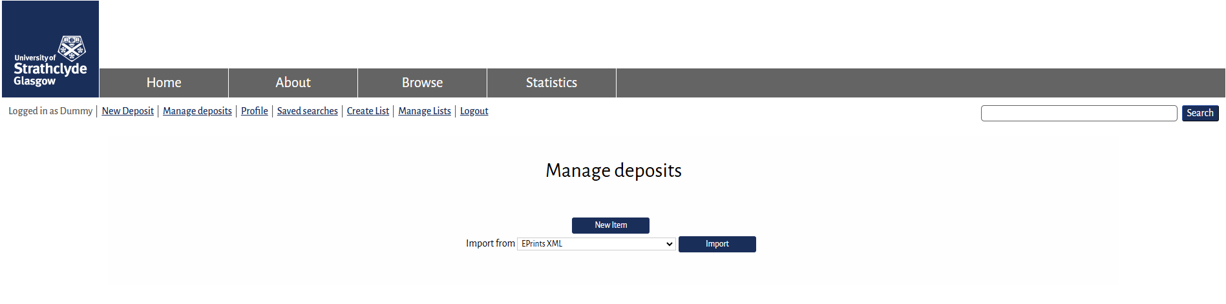
Q: Change “New Item” to “New Deposit” to be consistent with ribbon options?
- “Import from” – Import what, from where? Do we need this option?
- Do we need a Help button on this page rather then after they click ‘new item’?
Click on ‘New Item”
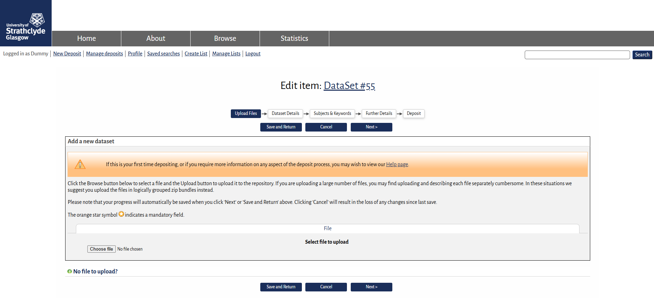
Q; D we want ‘Upload Files’ to be the first option or move to between ‘further details’ & ‘Deposit’
- Add individual file upload limit size to upload help text?
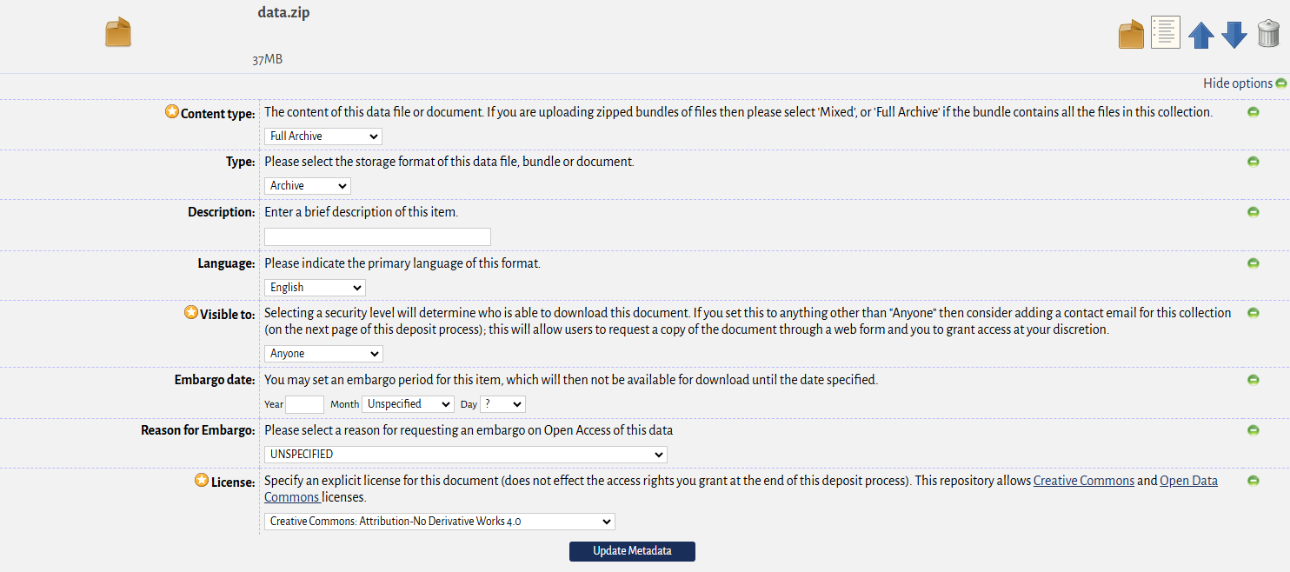
Need to edit Help info?
- Content type: advised to select “Mixed” but “Mixed” not a drop down menu option, Can we edit drop down menu options e.g, “Documentation” “additional Metadata” “Readme” are too similar & confusing
- Should “Description” be mandatory, or will general description in “dataset details” be enough?
- CC-BY 4.0 fixed a default license & say this in the help info?
Not sure what the function of “No file to upload” is? Will Users know what a URI is? No Help associated with this section.
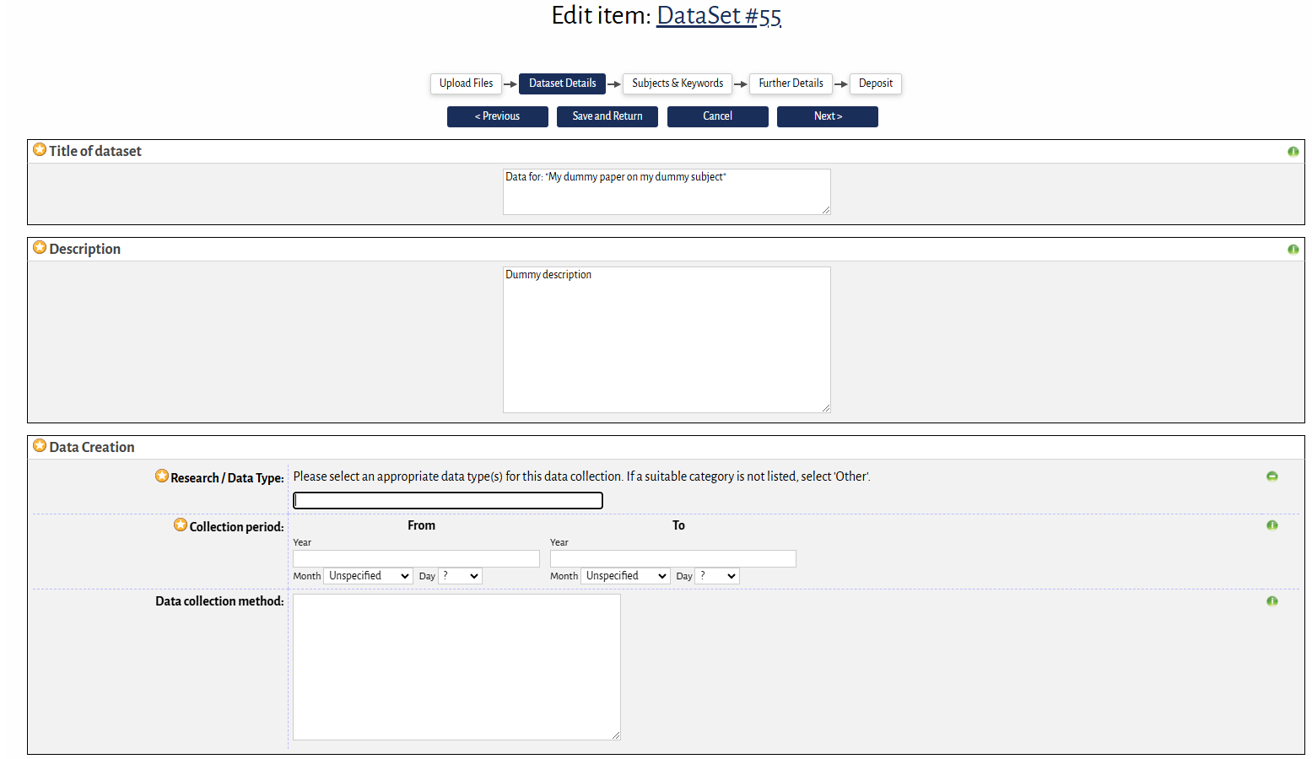
Q:
- Research/Data Type. Help says ‘select’ category, but no drop down menu to select from

